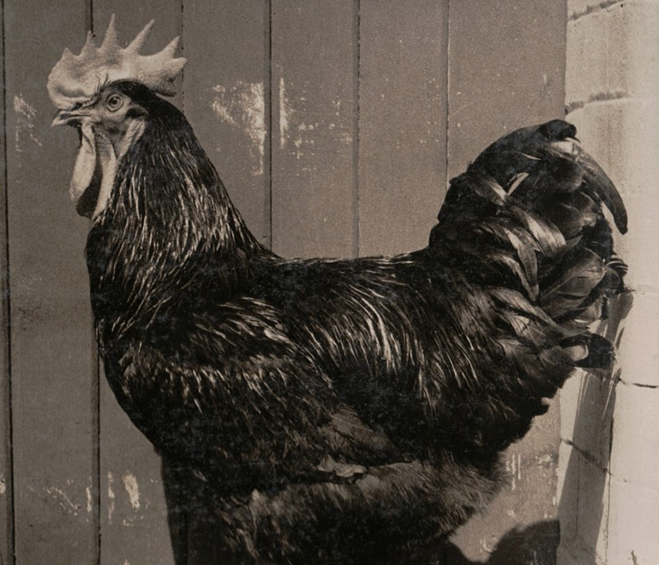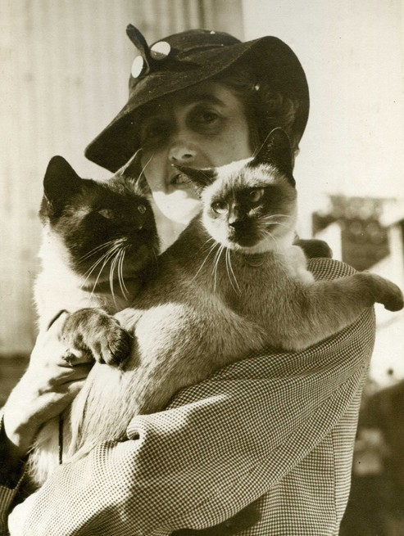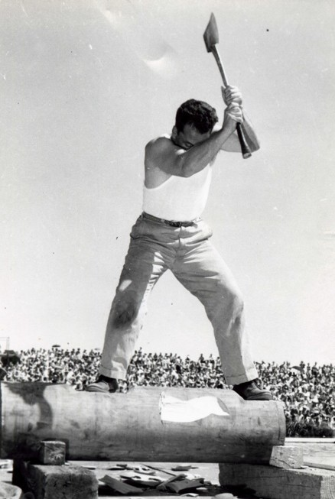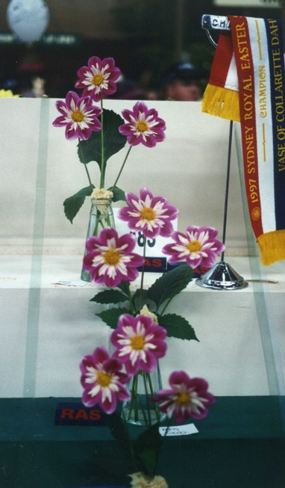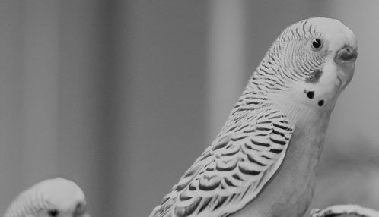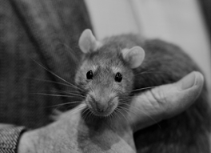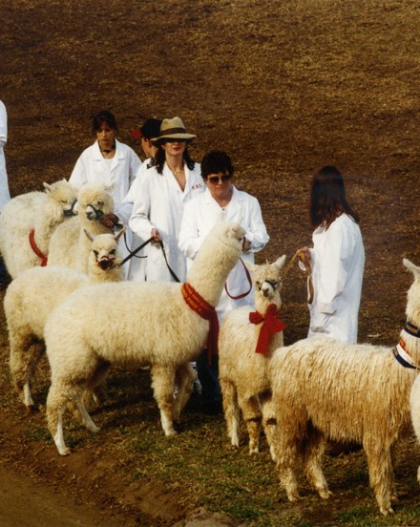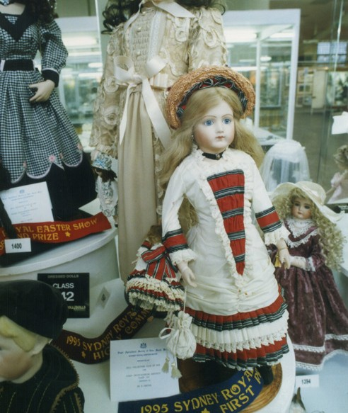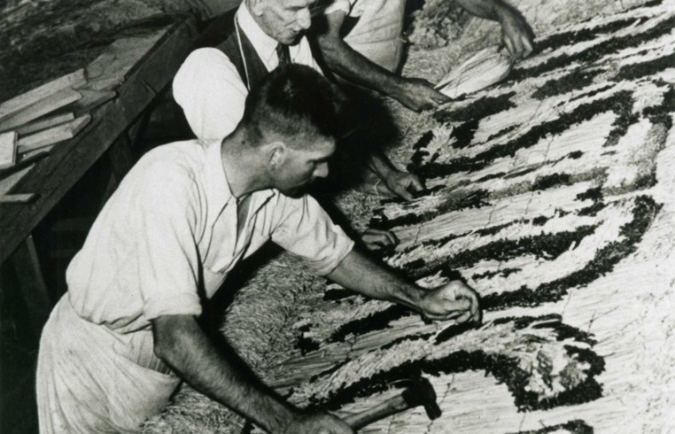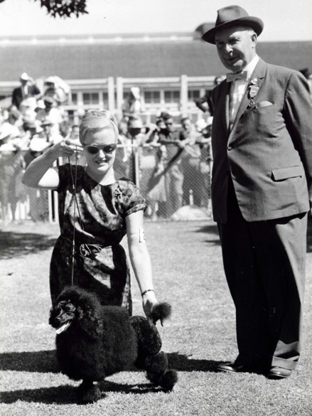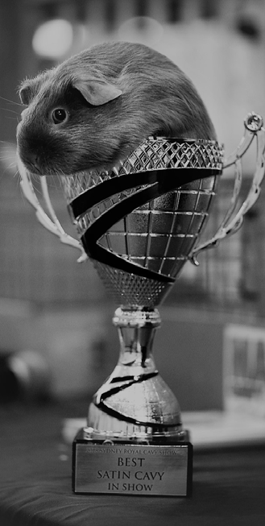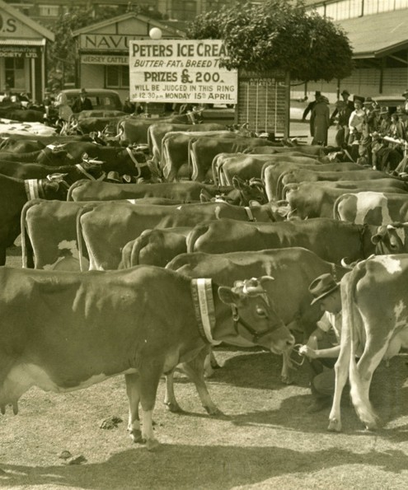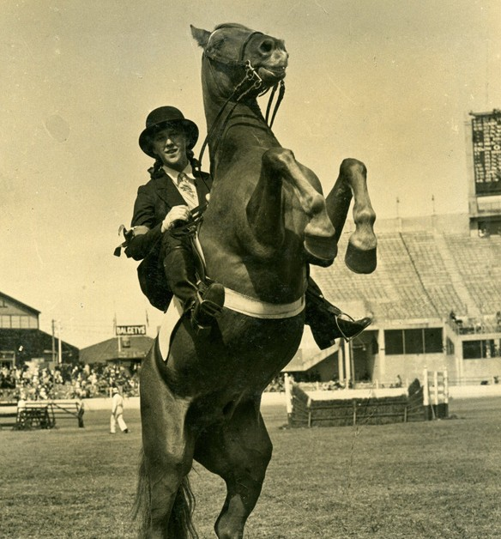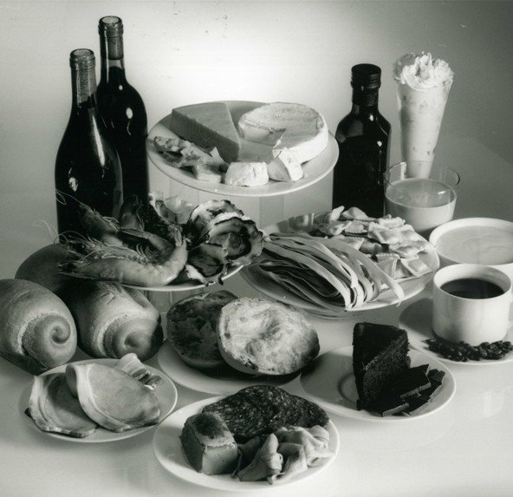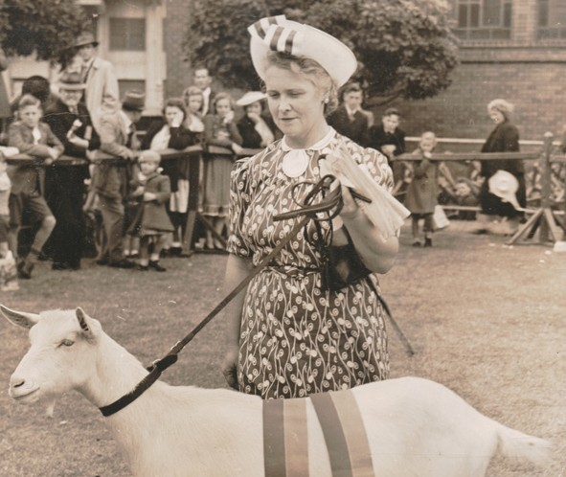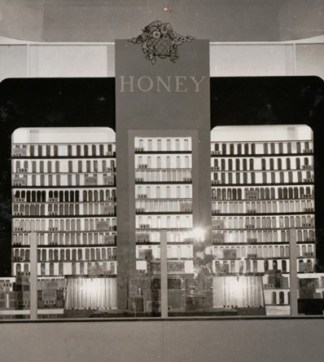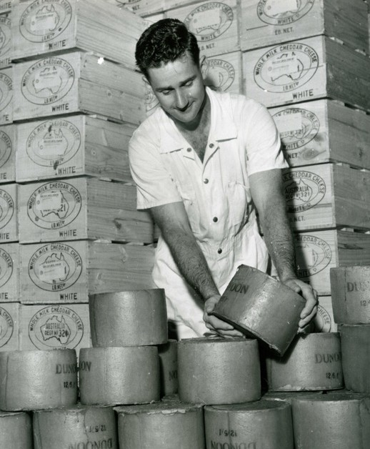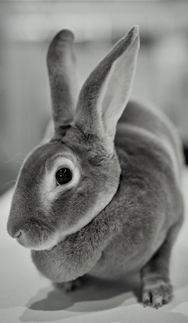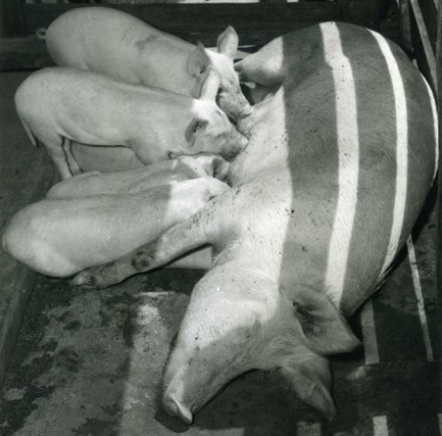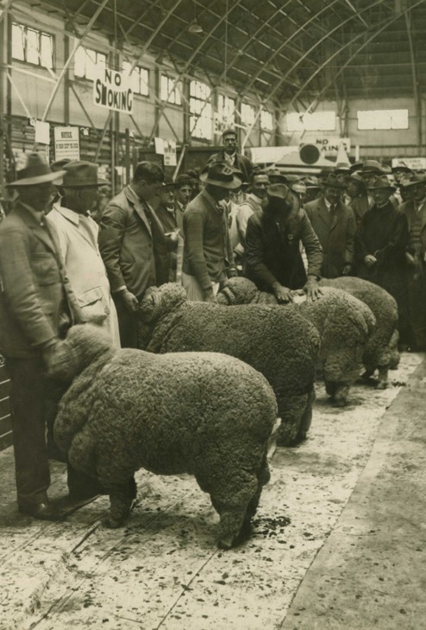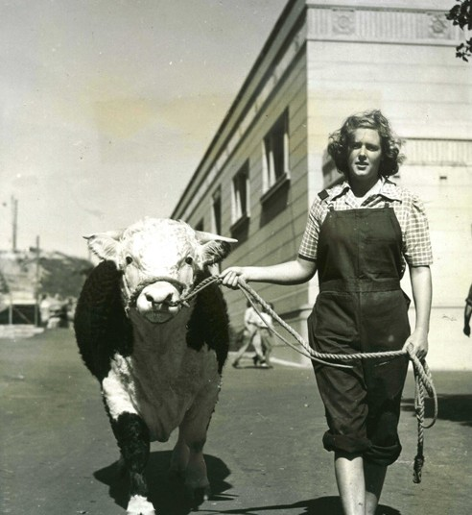

Schedule
Sydney Royal
Rat & Mice Show
8 - 19 April 2022 Sydney Showground Sydney Olympic Park www.rasnsw.com.au

Held under the Rules and Regulations of the NSW Fancy Rodent Society Inc in conjunction with the Royal Agricultural Society of New South Wales and judged to the standards of the NSW Fancy Rodent Society Inc.

CLOSING DATE OF ENTRY
Sunday, 20th March 2022

ENTER ONLINE AT
http://nfrs.com.au/orsm/

ENQUIRIES
Phone: 02 9596 1733 or 0400 470 388
(Steve)
Email: info@nfrs.com.au

ENTRY FEE
$3 per entry ($50 cap per membership). Non-Members entries are $5 each with no capping. Entries are entered online through the ORSM system on the Club website and you can use Paypal or make payment via bank transfer into the Club account, we will not be taking any payments on the day.
Details for electronic funds transfer are as follows:

Bank: National Australia Bank
Name of account: NSW Fancy Rodent Society
BSB: 082 330
Account number: 5511 28414

PARKING
Prepaid parking is available for all exhibitors at $30 per car – book online. Tickets are also available at the gates when you enter the carpark.

SHOW DATE
Friday, 8th April 2022

CONDITIONS OF ENTRY
A condition of entering into the competition is the strict adherence to the regulations.
Accordingly, Applications for Entry in the name of deceased person(s) are not eligible for entry.

EXHIBIT CONFIRMATION ADVICE
The exhibit conformation advice, otherwise known as a bench slip, indicates the class in which your Rat or Mouse has been entered and allows the exhibitor to enter the show with their exhibits.

SHOWGROUND ENTRY
In 2022 entry to the Showground by vehicle for dropping off exhibits will be through Gate 10 only. The vehicle may enter the site for the purposes of delivering exhibits during the specified delivery times only. It does not permit parking on site. The vehicle must be removed from site immediately after the exhibit is delivered.

Vehicles or passengers dropping off animals without a bump in pass (a window sticker for the car) and valid Royal Easter Show entry tickets will be denied entry to the Showgrounds and directed to contact the Domestic Animals Coordinator. Vehicles that remain onsite illegally will be infringed at owner’s expense.

The driver will need a valid Royal Easter Show entry ticket to re-enter the site on foot via the designated pedestrian entries after dropping off the animals and parking their vehicle off site. Two tickets will be provided for each competitor, via redemption through the Ticketmaster website with a unique voucher code that will be sent by mail. Then you can download the actual Entry Pass to show at the gate after printing it - or display on your smartphone.

Exhibitors are recommended to be equipped with hand sanitiser and face masks.

HALL
The Rat and Mouse Show will be held in the Pet Pavilion, Hall C on Riverina Ave inside the Showgrounds. Rats and Mice will be on exhibition from 9.30am until 5pm.

DISCLAIMER
The information contained in this publication is gathered for the purpose of

providing information to exhibitors and show patrons. The information is a compilation of information provided by third parties and the NSW Fancy Rodent Society Inc does not warrant its accuracy and advises that any such information may be subject to change or amended after publication and thereby unintentionally making the information incorrect.

If you require confirmation of the NSW Fancy Rodent Society Inc’s obligations and responsibilities, please contact the NSW Fancy Rodent Society Inc.

SPECIAL RAT AND MOUSE REGULATIONS
The Royal Agricultural Society of New South Wales’ General Regulations apply to all sections of the show, as do the rules and regulations of the NSW Fancy Rodent Society Inc. These Special Rat and Mouse Regulations apply to this section only.
Unless expressly stated in the General Regulations, if there is any inconsistency between the General Regulations and these Special Rat and Mouse Regulations, the Special Rat and Mouse Regulations prevail. Copies of all Royal Agricultural Society of New South Wales Regulations are available from the Administration Office at the Showground. General Regulations are also available at: www.eastershow.com.au.

- All Exhibits must be entered under the owner’s name. Stud prefixes will not be accepted as owners.

- Any protest must be in writing and lodged with the NSW Fancy Rodent Society Inc’s Secretary within 7 days of the show with a processing $10 fee (Cheque or Money Order made out to the NSW Fancy Rodent Society Inc.)

- Rats and Mice, other than exhibits, shall not be allowed in or within the precincts of the show during the conduct of the show.

- All Rats and Mice exhibited at the show must be fed and watered by the exhibitor. No exhibits are to be left alone at any time.
Rats and Mice must be at Hall C from 7.00am on Friday, 8th April 2022.

- No Rat or Mouse will be admitted to the Hall after 8am for examination by the Official Veterinarian of the Royal Agricultural Society of New South Wales. The examination will take place in the Veterinarian Room of the Hall. If approved, Rats and Mice must be benched at once. No person, except the owner or the owner’s representative will be allowed in the Hall until after the Rats and Mice have been benched. Any Rat or Mouse which shows symptoms of any disease, is infested by lice or mites, is pregnant and or dirty must be removed from the Showground at once.

- No Rat or Mouse shall be removed from the Hall between the hours of 8.30am and 5pm unless a veterinary certificate is produced stating that the Rat or Mouse is not fit to remain on the Bench.

- Rats and Mice may not leave the Hall until 5pm on Friday, 8th April 2022 unless approval has been obtained from the Chief Steward.

- Prior to judging there shall be no interior or exterior decorations or distinguishing objects in any show tank. The Judges will be instructed to pass any show tank so distinguished.

- No Rat or Mouse shall be removed from its show tank during the show for any purpose whatsoever without the authority of the Chief Steward.

- The NSW Fancy Rodent Society Inc and the Royal Agricultural Society of New South Wales will not, under any circumstances, hold itself responsible for any loss or misdelivery of livestock or other exhibits at the NSW Fancy Rodent Society Inc exhibition, or any damage thereto.

- Any exhibit which is unable to be handled or which is found to be under sedation will be disqualified. An exhibit

which cannot be handled by an Official of the NSW Fancy Rodent Society Inc at any time at the Show shall be deemed to be fractious and shall be reported.

- The age of all exhibits will be the actual age on the day of judging.

Rats:
- Kitten Class is one confined to Rats aged between 6 and 12 weeks old on the day of the show.
- Adult classes are confined to Rats aged over 12 weeks old on the date of the show.

Mice:
- Kitten Class is one confined to Mice aged between 6 and 10 weeks old on the day of the show.
- Adult classes are confined to Mice aged over 10 weeks old on the date of the show.

SICK OR DISEASED ANIMALS
If, in the opinion of a qualified veterinarian appointed by the Royal Agricultural Society of New South Wales, an animal on the Showground be so injured or be so affected by sickness, disease or other ailment as to warrant its destruction or its removal from the Showground as the case may be, the Royal Agricultural Society of New South Wales shall be entitled to have the animal destroyed and/or require that the animal to be forthwith removed from the Showground and the exhibitor, in receipt of such notice, shall forthwith remove such animal and failing such removal within the time prescribed by the Royal Agricultural Society of New South Wales, the Royal Agricultural Society of New South Wales may remove the animal or cause the animal to be removed and all costs and expenses of removal shall be borne by the exhibitor and shall be refunded to the Royal Agricultural Society of New South Wales.

Each such animal shall at all times be at the sole risk and responsibility of the exhibitor, and the person or persons removing the animal shall at all times be deemed to be the agents of the exhibitor and all acts and
omissions on the part of such person or persons shall be deemed to be the acts and omissions of the exhibitor who shall indemnify and hold indemnified the Royal Agricultural Society of New South Wales its servants and agents from all claims whatsoever in respect of the animal whether by reason of any loss or injury to or caused by the animal or because of transportation, feeding or housing or otherwise howsoever. The NSW Fancy Rodent Society Inc may, in any circumstances which it thinks fit, refuse to accept the entry of an exhibit or may at any time cancel any entry already accepted and may disqualify the relative exhibit from competing or exhibiting in any specific class or classes or events and without prejudice to the generality of the foregoing of the NSW Fancy Rodent Society Inc shall so act if a report of the veterinarian upon the relative exhibit discloses that the veterinarian considers or finds that the exhibit:

- Is affected with any contagious or infectious disease or is obviously pregnant or is known to have or is suspected to have been brought onto the Showground from a stud in which an animal was affected by or suffering from a contagious disease within 30 days or the relevant incubation period, whichever is shorter, prior to the date upon which the relevant exhibit was brought onto the Showground.

- Shows any sign of any surgical or other artificial interference, which is calculated to deceive or is capable of deceiving either Judges or spectators.

All exhibits must be brought into the Hall securely contained in an adequate carrying receptacle. The Judge may in their discretion and without assigning any reason therefor, decline to make an award in respect of any exhibit.

If an exhibit is not in its cage when the judges are called to the floor, the exhibit will be automatically disqualified. The use of

methylated spirits or atomiser sprays in the Hall are not allowed. Hand sanitisers using an alcohol base are permitted.

An exhibitor or handler of an exhibit shall not use talcum powder or other like substances on an exhibit whilst the exhibit is caged or in the vicinity of the cages. No Rat or Mouse which is pregnant, lactating or sick, shall be exhibited.

PROHIBITED SUBSTANCES
Please refer to the General Regulations of the Royal Agricultural Society of New South Wales.

RIBBONS
Subject to the regulations, ribbons may be awarded throughout the Rat and Mouse Classes for 1st, 2nd and further places, in accordance to the following table:
Up to 5 exhibits 3 ribbons
Up to 10 exhibits 4 ribbons
Up to 20 exhibits 5 ribbons
21 exhibits and over 6 ribbons

SPECIAL PRIZES
NSW Fancy Rodent Society Inc and the Royal Agricultural Society of New South Wales will present special prizes as follows:

Grand Champion Rat In Show Champion Rat In Show
Reserve Champion Rat In Show

Grand Champion Mouse In Show Champion Mouse In Show Reserve Champion Mouse In Show

Best Pet Rat In Show Reserve Pet Rat In Show
Best Junior Rat Exhibitor In Show Best Kitten Rat In Show
Best Conformation Rat In Show Best Rat Breeder Group In Show Best Standard Rat In Show
Best Soft Coat Rat In Show Best Coarse Coat Rat In Show Best Patchwork Rat In Show
Best Pet Mouse In Show Reserve Pet Mouse In Show
Best Junior Mouse Exhibitor In Show Best Kitten Mouse In Show
Best Conformation Mouse In Show Best Mouse Breeder Group In Show Best Standard Mouse In Show
Best Long Coat Mouse In Show Best Rex Mouse In Show
Best Long Coat Rex Mouse In Show Best Manx Mouse In Show
Best Variable Coat Mouse In Show Best Display

PET AND SPECIALTY CLASSES

Class 1 – Young Pet Rat Class 2 – Adult Pet Rat Class 3 – Senior Pet Rat
Class 4 – Junior Rat Exhibitor Class 5 – Rat Kitten
Class 6 – Companion Rat Class 7 – Young Pet Mouse Class 8 – Adult Pet Mouse Class 9 – Senior Pet Mouse
Class 10 – Junior Mouse Exhibitor Class 11 – Mouse Kitten
Class 12 – Companion Mouse RAT TYPE CLASSES
Class 13 – Rat Breeder Group Class 14 – Conformation Rat

Class 15 – Standard Self Ticked Rat Class 16 – Standard Self Non-Ticked Rat Class 17 – Standard Marked Ticked Rat
Class 18 – Standard Marked Non-Ticked Rat

Class 19 – Soft Self Ticked Rat Class 20 – Soft Self Non-Ticked Rat Class 21 – Soft Marked Ticked Rat
Class 22 – Soft Marked Non-Ticked Rat

Class 23 – Coarse Self Ticked Rat Class 24 – Coarse Self Non-Ticked Rat Class 25 – Coarse Marked Ticked Rat
Class 26 – Coarse Marked Non-Ticked Rat Class 27 – Patchwork Rat

MOUSE TYPE CLASSES

Class 28 – Mouse Breeder Group Class 29 – Conformation Mouse

Class 30 – Standard Self Mouse Class 31 – Standard Fox/Tan Mouse Class 32 – Standard Shaded Mouse Class 33 – Standard Ticked Mouse Class 34 – Standard Marked Mouse

Class 35 – Long Coat Self Mouse Class 36 – Long Coat Fox/Tan Mouse Class 37 – Long Coat Shaded Mouse Class 38 – Long Coat Ticked Mouse Class 39 – Long Coat Marked Mouse

Class 40 – Rex Self Mouse Class 41 – Rex Fox/Tan Mouse Class 42 – Rex Shaded Mouse Class 43 – Rex Ticked Mouse Class 44 – Rex Marked Mouse

Class 45 – Long Coat Rex Self Mouse Class 46 – Long Coat Rex Fox/Tan Mouse Class 47 – Long Coat Rex Shaded Mouse Class 48 – Long Coat Rex Ticked Mouse Class 49 – Long Coat Rex Marked Mouse

Class 50 – Manx Self Mouse Class 51 – Manx Fox/Tan Mouse Class 52 – Manx Shaded Mouse Class 53 – Manx Ticked Mouse Class 54 – Manx Marked Mouse

Class 55 – Long Coat Manx Self Mouse Class 56 – Long Coat Manx Fox/Tan Mouse Class 57 – Long Coat Manx Shaded Mouse Class 58 – Long Coat Manx Ticked Mouse Class 59 – Long Coat Manx Marked Mouse

Class 60 – Rex Manx Self Mouse Class 61 – Rex Manx Fox/Tan Mouse Class 62 – Rex Manx Shaded Mouse Class 63 – Rex Manx Ticked Mouse Class 64 – Rex Manx Marked Mouse

Class 65 – Long Coat Rex Manx Self Mouse Class 66 – Long Coat Rex Manx Fox/Tan Mouse
Class 67 – Long Coat Rex Manx Shaded
Mouse
Class 68 – Long Coat Rex Manx Ticked Mouse
Class 69 – Long Coat Rex Manx Marked Mouse

Class 70 – Hairless Mouse Class 71 – Patchwork Mouse
Class 72 – Manx Hairless Mouse Class 73 – Manx Patchwork Mouse

